**Project Design Phase-1**

Solution Architecture

**SMART WASTE MANAGEMENT SYSTEM FOR**

**METEROPOLITAN CITIES**

TEAM ID:PNT2022TMID52274

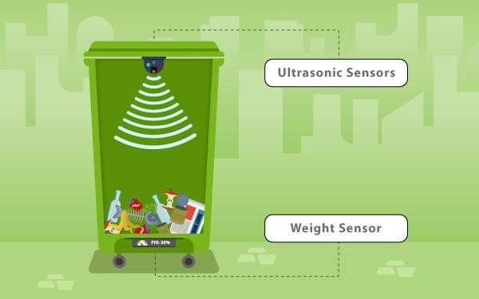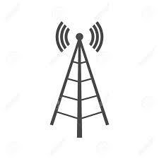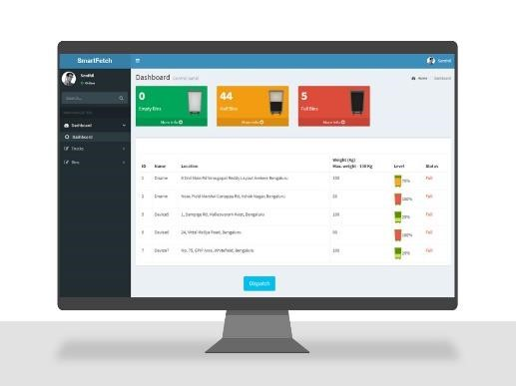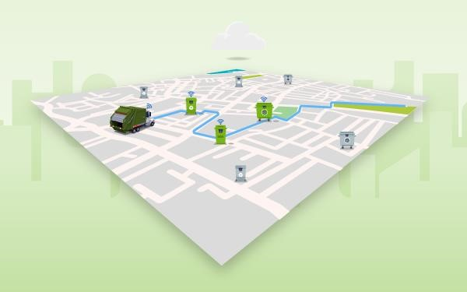

Smart waste

collection bin

Cloud Service

Network access point

Send data to driver

Optimize the waste

collection route

Team ID:

PNT2022TMID52274

**Design:**

* Garbage level detection in bins.
* Getting the weight of the garbage in the bin.
* Alerts the authorized person to empty the bin whenever the bins are full.
* Garbage level of the bins can be monitored through a web App.
* We can view the location of every bin in the web application by sending GPS location from the device.

**Software and system required:**

* Python IDLE
* 4GB processor and OS-Windows/Linux/MAC

Cloud service:

Includes IBM Watson IoT Platform, Node RED,Web UI.

Cloud platform that supports sensing as a service